Chapter 8, Problem 20.

The switch in the circuit of Fig. 8.74 has been closed for a long time but is opened at t = 0. Determine i(t) for t > 0.

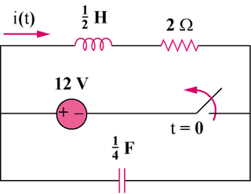
30 V

Figure 8.74
For Prob. 8.30.

